16.default constructor
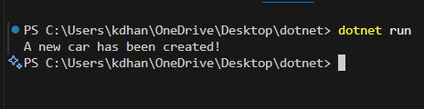
Parameterized constructor
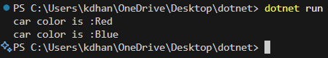
Overloading constructor
